Lane Edge Detection on Nexys A7 / Artix-7 FPGA Using Sobel Filter

1. Project Concept
Concept: This project implements a simple lane-edge detection system on an FPGA using VHDL. A road image is stored inside the FPGA as a grayscale ROM image. The FPGA reads the image pixel by pixel, processes it with a 3 x 3 Sobel filter, and displays either the original image or the Sobel edge-detected output on a VGA monitor.
Why ROM input is used: A live camera is not used in this version. Instead, a fixed road image is stored in image ROM. This keeps the project easier to implement, test, and explain.
Image resolution: The stored image is 160 x 120 pixels. The VGA output is 640 x 480 pixels, so the image is scaled by a factor of 4 to fill the display.

2. Design Source Files

VHDL file | Purpose | Beginner explanation
Lane_Detection_using_Sobel_Filter_top.vhd | Top-level VHDL file | Connects all other modules and board I/O.
VGA_Display_640x480.vhd | VGA timing generator | Creates x/y position, pixel_ce, visible area, Hsync and Vsync.
image_rom_160x120.vhd | Image ROM | Stores the grayscale road image as pixel values.
Sobel_Filter_3x3.vhd | Sobel filter module | Detects image edges using a 3 x 3 pixel window.
Implemented_in_Artix7_100T.xdc | Constraints file | Maps VHDL ports to real FPGA board pins.

3. Inputs and Outputs
Signal | Direction | Purpose
CLK100MHZ | Input | 100 MHz clock from the Nexys A7 board
SW0 | Input | Selects original image or Sobel edge output
vgaRed[3:0] | Output | 4-bit VGA red signal
vgaGreen[3:0] | Output | 4-bit VGA green signal
vgaBlue[3:0] | Output | 4-bit VGA blue signal
Hsync | Output | VGA horizontal synchronization signal
Vsync | Output | VGA vertical synchronization signal

4. Display Modes
SW0 value | VGA output
0 | Original road image
1 | Sobel edge-detection output

5. Block Diagram
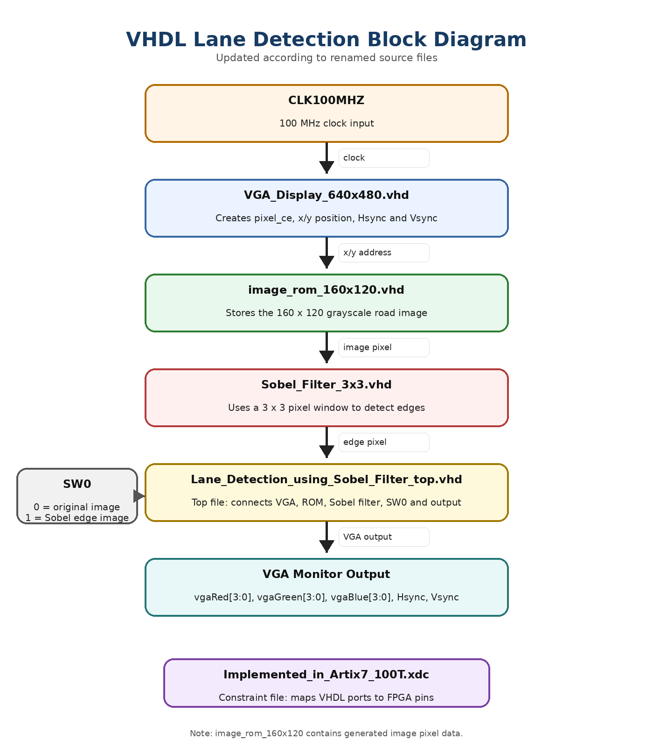

6. Working Principle
- VGA_Display_640x480 creates the VGA timing signals and gives the current x/y pixel position.
- The x/y position is converted to a 160 x 120 image address and sent to image_rom_160x120.
- image_rom_160x120 outputs one grayscale road-image pixel.
- Sobel_Filter_3x3 builds a 3 x 3 pixel window and calculates the Sobel edge strength.
- Lane_Detection_using_Sobel_Filter_top selects original image or Sobel output using SW0.
- The selected grayscale pixel is sent to the VGA RGB outputs, together with Hsync and Vsync.

7. Limitation
This project is a ROM-based FPGA demonstration. It does not use a live camera. The purpose is to show how a stored road image can be processed with a Sobel filter in VHDL and displayed on a VGA monitor.

